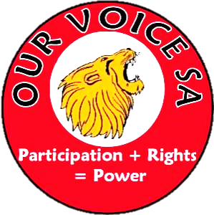

Are you a person living with an intellectual disability?
Would you like to have more power in your life?
Would you like to learn more about Self-Advocacy?
Our Voice SA invites you to attend these Information Sessions.
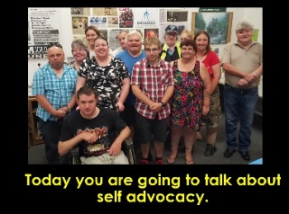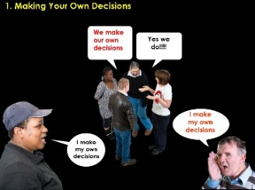
Session 1 Session 2
Self Advocacy Decision making
December 10 December 17
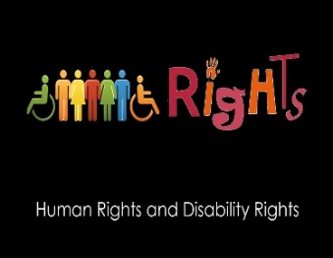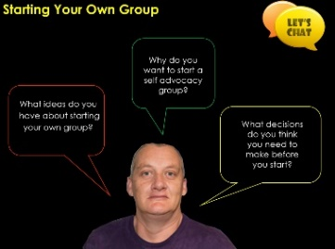
Session 3 Session 4
Human Rights Peer Support
December 17 January 14

Where: Kadina DHS,
4 Draper Street
Time: 10:00am – 3:00pm
Lunch provided.

If you are unsure, please come to the first session to find out more information.
For more information and to register your interest please ring or email Alison 8373 8321 alisonv@purpleorange.org.au
We look forward to meeting you

